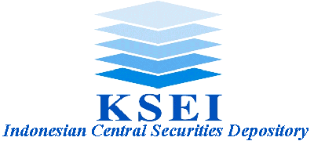

No. KSEI-3431/JKS/0506 Jakarta, May 3rd 2006

Attention:

Board of Directors

Account Holder
PT Kustodian Sentral Efek Indonesia (KSEI)

Re: | PT Bank Niaga Tbk (BNGA) Cash Dividend Ratio

Referring to KSEI Announcement No. KSEI-2738/JKS/0406 dated April 12th 2006 regarding Time Frame for Cash Dividend Distribution of Bank Niaga PT, Tbk (BNGA) Share and PT Bank Niaga Tbk (BNGA) Letter No. 141/RPH/CA-KP/V/06 dated May 3rd 2006 regarding PT Bank Niaga Tbk Confirmation on Amount of Dividend per-Share, we herewith inform that the amount of dividend per-share to be paid on May 17th 2006 is Rp. 5,82 (five Rupiahs and eighty two cents) per-share.

It is thus conveyed. We thank you for your attention and kind cooperation.

PT Kustodian Sentral Efek Indonesia

Sulistyo Budi Dharma Setyadi
Central Depository Services Div. Head Customer Relations Dept. Head
Central Depository Services Division

c.c. to:
- Board of Directors - PT Bursa Efek Jakarta.
- Board of Directors - PT Bursa Efek Surabaya.
- Board of Directors - PT Kliring Penjaminan Efek Indonesia.
- Board of Directors - PT Bank Niaga Tbk.
- Board of Directors - PT Sirca Datapro Perdana.

PT Kustodian Sentral Efek Indonesia
Gedung Bursa Efek Jakarta Tower 1 Lt. 5 Jl. Jend. Sudirman Kav. 52-53 Jakarta 12190 Indonesia
Ph. (62-21) 5299-1099 Fax. (62-21) 5299-1199 PO Box 3855 Jakarta 10038

